 

# Placement Empowerment Program

***Cloud Computing and DevOps Centre***

**Create a Simple Backup Script**

Create a script that backups up your entire Git repository to a local folder daily

Name: Advik S.K

Department: Ads



# Introduction

Automating Git repository backups helps prevent data loss by regularly saving copies of your repositories. This guide will walk you through creating a simple script using tar (Linux/macOS) or robocopy (Windows) to back up your Git repositories to a local folder daily, with automation via cron or Task Scheduler.

# Overview

This project involves creating an automated backup script for Git repositories using shell scripting (tar) on Linux/macOS or batch scripting (robocopy) on Windows. The script will copy repositories to a designated backup folder daily, ensuring data safety. Automation will be handled using cron jobs (Linux/macOS) or Task Scheduler (Windows), eliminating the need for manual backups.

# Objectives

**Objectives:**

* Automate daily backups of Git repositories to a local folder.
* Use shell scripting (tar) for Linux/macOS and batch scripting (robocopy) for Windows.
* Ensure data safety by maintaining up-to-date repository copies.
* Implement task automation using cron (Linux/macOS) or Task Scheduler (Windows).
* Minimize manual effort while securing repository data efficiently.

# Step-by-Step Overview Step

1

## **Choose Your Backup Location**

Decide where you want to store your backup files.

•Example for **C:\Users\advik\OneDrive\Documents\100 days chllange**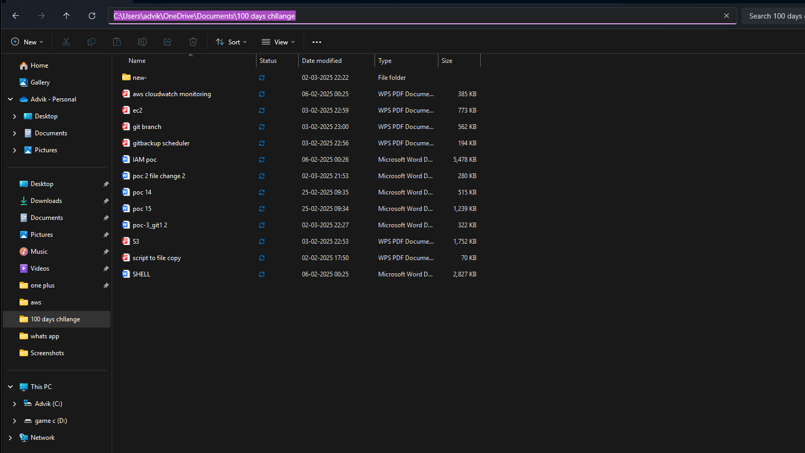

## Step 2

### Create the Backup Script

1. Open Notepad and paste the following script:

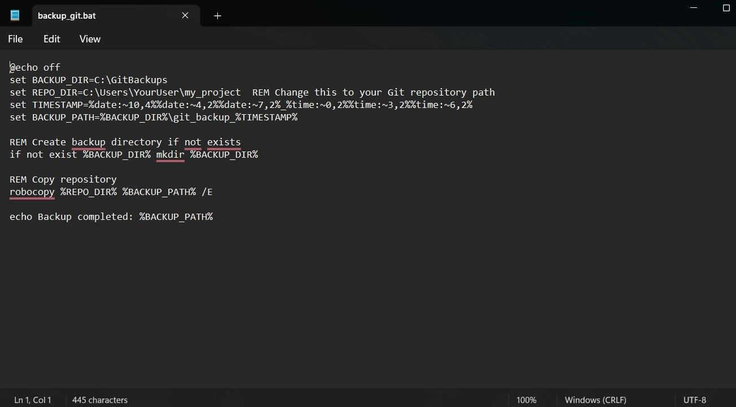

1. Save the file as backup_git.bat.

3.Double-click the script to test if it runs successfully.

## Step 3

### Automate the Backup

Open **Task Scheduler** (Win + R, then type taskschd.msc).

Click **Create Basic Task**.

Name it **Git Backup** and click **Next**.

Choose **Daily**, then click **Next**.

Set the time you want the script to run (e.g., **2:00 AM**), then click **Next**.

Choose **Start a Program**, then **Browse** for backup_git.bat.

Click **Finish**.

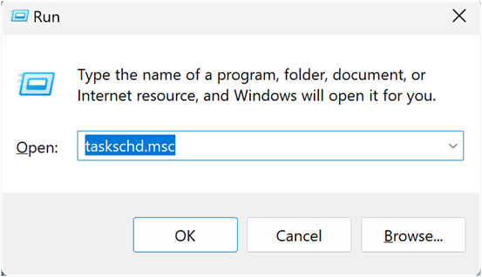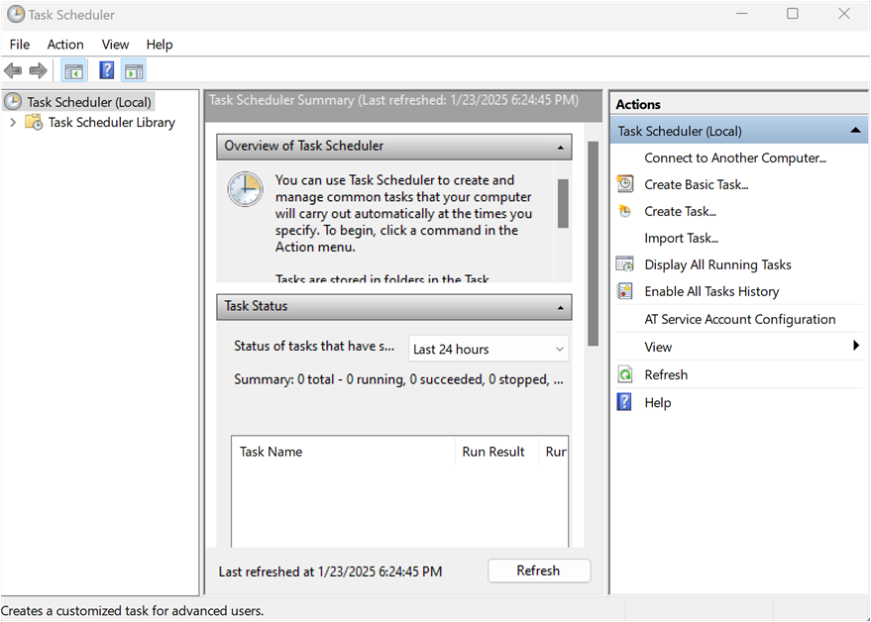

## Step 4

### Step 4: Verify Your Backups

* Check the **backup directory** (~/git_backups on Linux/macOS or C:\GitBackups on Windows) to ensure backups are created.
* Open a backup file to confirm it contains your Git repository.